

Compensation and Pension Record Interchange (CAPRI)

Leukemia

Disability Benefits Questionnaire (DBQ)

Workflow

November 2010

Department of Veterans Affairs
Office of Enterprise Development
Management & Financial Systems

Revision History

Date | Description (Patch # if applicable) | Author | Technical Writer
08/02/2010 | Document created | C. Gawronski | J. Headen
08/11/10 | Incorporated ICD and other new changes | C. Gawronski | J. Headen
10/28/10 | Changed wording in standard note in introduction for Patch 159. | C.Gawronski | N/A

Table of Contents

1 Introduction 1
1.1 Purpose 1
1.2 Overview 1
2 Leukemia DBQ – History Tab 2
2.1 Name of patient/Veteran 2
2.2 Section 1. Diagnosis 2
2.3 Section 2. Status of disease 5
2.4 Section 3. Treatment 5
2.5 Section 4. Residual complications 6
2.6 Section 5. Functional impact 10
2.7 Section 6. Remarks 11
3 Leukemia AMIE Worksheet 12

Table of Figures and Tables

Figure 1: Template Example: DBQ - Standard VA Note 1
Figure 2: Print Exmaple: DBQ – Standard VA Note 1
Figure 3: Template Example: DBQ – Leukemia – Name of patient/Veteran 2
Figure 4: Print Example: DBQ – Leukemia – Name of patient/Veteran 2
Figure 5: Template Example: DBQ – Leukemia – 1. Diagnosis 4
Figure 6: Print Example: DBQ – Leukemia – 1. Diagnosis 4
Figure 7: Template Example: DBQ – Leukemia – 2. Status of disease 5
Figure 8: Print Example: DBQ – Leukemia – 2. Status of disease 5
Figure 9: Template Example: DBQ – Leukemia – 3. Treatment 6
Figure 10: Print Example: DBQ – Leukemia – 3. Treatment 6
Figure 11: Template Example: DBQ – Leukemia – 4. Residual complications 9
Figure 12: Print Example: DBQ – Leukemia – 4. Residual complications 10
Figure 13: Template Example: DBQ – Leukemia – 5. Functional impact 11
Figure 14: Print Example: DBQ – Leukemia – 5. Functional impact 11
Figure 15: Template Example: DBQ – Leukemia – 6. Remarks 11
Figure 16: Print Example: DBQ – Leukemia – 6. Remarks 11

Table 1: Rules: DBQ – Leukemia – Name of patient/Veteran 2
Table 2: Rules: DBQ – Leukemia – 1. Diagnosis 3
Table 3: Rules: DBQ – Leukemia – 2. Status of disease 5
Table 4: Rules: DBQ – Leukemia – 3. Treatment 6
Table 5: Rules: DBQ – Leukemia – 4. Residual complications 7
Table 6: Rules: DBQ – Leukemia – 5. Functional impact 11
Table 7: Rules: DBQ – Leukemia – 6. Remarks 11

Introduction

Purpose
This document provides a high level overview of the contents found on the LEUKEMIA Disability Benefits Questionnaire (DBQ). The DBQ can be populated via an online template within the CAPRI C&P Worksheets tab and then printed OR it can be printed via AMIE (AUTOMATED MEDICAL INFORMATION EXCHANGE) and then manually populated. This document contains the edit rules for the template as well as an example of how the template will look online in CAPRI or printed from CAPRI. It also contains the layout for the AMIE worksheet to depict how it will look when printed from AMIE.

For more detailed information on standard template functionality not covered in this document, please refer to the C&P Worksheet Tab Functionalities section of the CAPRI GUI User Guide.

Overview
The LEUKEMIA DBQ provides the ability to capture information related to Hairy Cell and Other B-Cell Leukemia’s and treatment.

Each DBQ template contains a standard footer containing a note stating that the “VA may request additional medical information, including additional examinations if necessary to complete VA’s review of the Veteran’s application”. (see Figure 1 and 2).

Figure 1: Template Example: DBQ - Standard VA Note
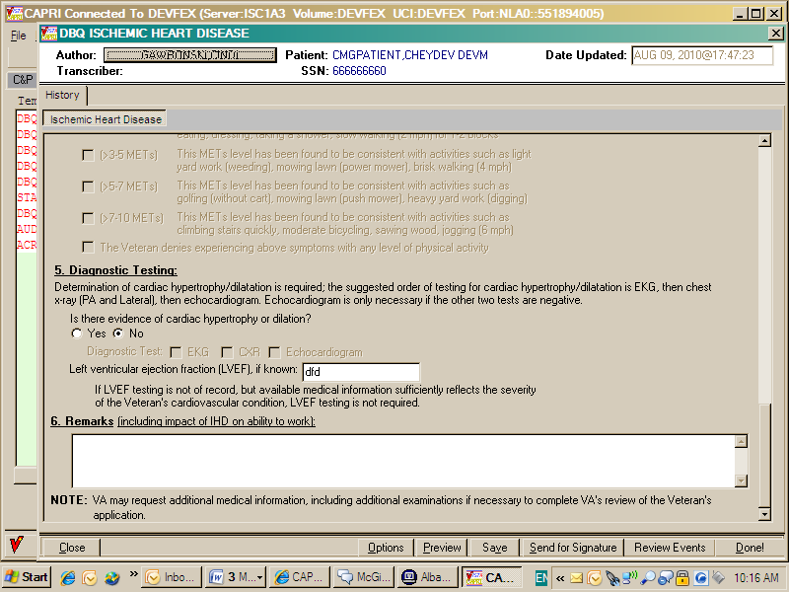

Figure 2: Print Exmaple: DBQ – Standard VA Note

NOTE: VA may request additional medical information, including additional

examinations if necessary to complete VA's review of the Veteran's application.

A number of fields on the LEUKEMIA template are mandatory and require a response (value) prior to the exam being marked as completed. Some questions may activate a Pop-up window displaying information as to each question that needs to be answered before the template can be completed.

Leukemia DBQ – History Tab

Name of patient/Veteran
All questions in this section may be answered as described by the rules below. If all mandatory questions are not answered, the error message(s) will appear in a popup window as depicted below.

Table 1: Rules: DBQ – Leukemia – Name of patient/Veteran
Field/Question | Field Disposition | Valid Values | Format | Error Message
Disability Benefits Questionnaire | Disabled, Read-Only | N/A | N/A | N/A
Hairy Cell and Other B-Cell Leukemias | Disabled, Read-Only | N/A | N/A | N/A
Name of patient/Veteran: | Enabled, Mandatory | N/A | Free Text | Please enter the name of the patient/Veteran.
Your patient is applying to the U. S. Department of Veterans Affairs (VA) for disability benefits. VA will consider the information you provide on this questionnaire as part of their evaluation in processing the Veteran’s claim. | Disabled, Read-Only | N/A | N/A | N/A

Figure 3: Template Example: DBQ – Leukemia – Name of patient/Veteran
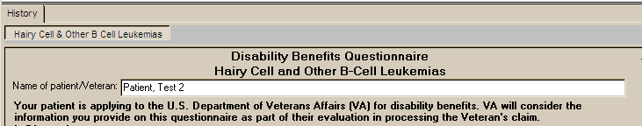

Figure 4: Print Example: DBQ – Leukemia – Name of patient/Veteran

Disability Benefits Questionnaire
Hairy Cell and Other B-Cell Leukemias
Name of patient/Veteran: Patient, Test 2
Your patient is applying to the U.S. Department of Veterans Affairs (VA) for
disability benefits. VA will consider the information you provide on this
questionnaire as part of their evaluation in processing the Veteran's claim.

Section 1. Diagnosis
The question “Does the patient/Veteran now have or has he/she ever been diagnosed with hairy cell leukemia or any other B-cell leukemia?” must be answered before the template can be completed.
- If it is answered with Yes, all other questions requiring an answer as described by the rules in this document must be answered before the template can be completed.
- If it is answered with No, the template may be completed without answering any additional questions or the user may input answers to any of the optional questions as indicated by the rules described in this document.

Note: Some questions will activate secondary question(s) when answered. If a secondary question is answered and the primary question that triggered the secondary question is unanswered or if answered in a way where this information is no longer required, the previously entered data will be removed and the question may become disabled if it is no longer relevant.

All questions will be printed even if they have not been answered.

If all mandatory questions are not answered, the error message(s) will appear in a popup window as depicted below and must be answered before this template can be completed.

Table 2: Rules: DBQ – Leukemia – 1. Diagnosis
Field/Question | Field Disposition | Valid Values | Format | Error Message
1.Diagnosis | Disabled, Read-Only | N/A | N/A | N/A
Does the Veteran now have or has he/she ever been diagnosed with hairy cell leukemia or any other B-cell leukemia? | Enabled, Mandatory, Choose one valid value | [Yes; No] | N/A | Please answer the question: Does the Veteran now have or has he/she ever been diagnosed with hairy cell leukemia or any other B-cell leukemia?
NOTE: Provide only diagnoses that pertain to hairy cell leukemia or any other B-cell leukemias. | Disabled, Read-Only | N/A | N/A | N/A
Diagnosis #1: | If diagnosis = Yes; Enabled, Mandatory  Else; Enabled, Optional | N/A | Free Text | Please enter diagnosis #1.
ICD code: | If diagnosis = Yes; Enabled, Mandatory  Else; Enabled, Optional | N/A | Free Text | Please enter the ICD code for diagnosis #1.
Date of diagnosis #1: | If diagnosis = Yes; Enabled, Mandatory  Else; Enabled, Optional | N/A | Free Text | Please enter the date of diagnosis #1.
Diagnosis #2: | Enabled, Optional | N/A | Free Text | N/A
ICD code: | If Diagnosis #2 is populated; Enabled, Mandatory  Else; Enabled, Optional | N/A | Free Text | Please enter the ICD code for diagnosis #2.
Date of diagnosis #2: | If Diagnosis #2 is populated; Enabled, Mandatory  Else; Enabled, Optional | N/A | Free Text | Please enter the date of diagnosis #2.
Diagnosis #3: | Enabled, Optional | N/A | Free Text | N/A
ICD code: | If Diagnosis #3 is populated; Enabled, Mandatory  Else; Enabled, Optional | N/A | Free Text | Please enter the ICD code for diagnosis #3.
Date of diagnosis #3: | If Diagnosis #3 is populated; Enabled, Mandatory  Else; Enabled, Optional | N/A | Free Text | Please enter the date of diagnosis #3.
If additional diagnoses that pertain to hairy cell leukemia or any other B-cell leukemia, list using above format: | Enabled, Optional | N/A | Free Text | N/A

Figure 5: Template Example: DBQ – Leukemia – 1. Diagnosis
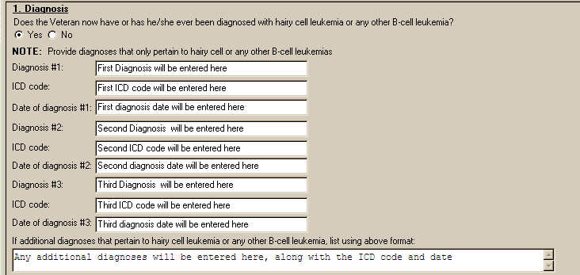

Figure 6: Print Example: DBQ – Leukemia – 1. Diagnosis

1. Diagnosis

------------

Does the Veteran now have or has he/she ever been diagnosed with hairy

cell leukemia or any other B-cell leukemia? [X] Yes [ ] No

NOTE: Provide diagnoses that only pertain to hairy cell or any other

B-cell leukemias

Diagnosis #1: First Diagnosis will be entered here

ICD code: First ICD code will be entered here

Date of diagnosis #1: First diagnosis date will be entered here

Diagnosis #2: Second Diagnosis will be entered here

ICD code: Second ICD code will be entered here

Date of diagnosis #2: Second diagnosis date will be entered here

Diagnosis #3: Third Diagnosis will be entered here

ICD code: Third ICD code will be entered here

Date of diagnosis #3: Third diagnosis date will be entered here

If additional diagnoses that pertain to hairy cell leukemia or any other

B-cell leukemia, list using above format: Any additional diagnoses will

be entered here, along with the ICD code and date

Section 2. Status of disease
All questions in this section may be answered as described by the rules below. If all mandatory questions are not answered, the error message(s) will appear in a popup window as depicted below.

Table 3: Rules: DBQ – Leukemia – 2. Status of disease
Field/Question | Field Disposition | Valid Values | Format | Error Message
2.Status of disease | If diagnosis = Yes; Enabled, Mandatory, Choose one valid value  Else; Enabled, Optional | [Active;  Remission] | N/A | Please indicate the status of the disease.

Figure 7: Template Example: DBQ – Leukemia – 2. Status of disease
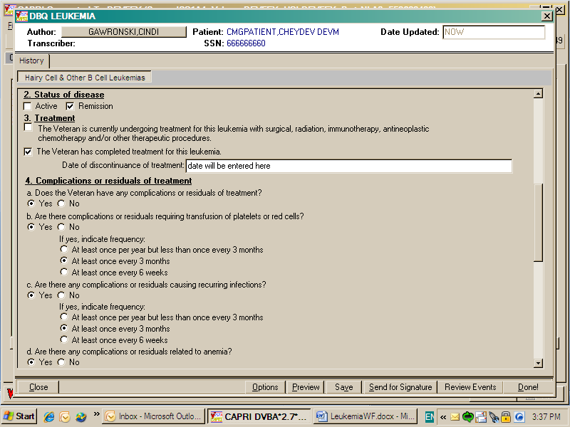

Figure 8: Print Example: DBQ – Leukemia – 2. Status of disease

2. Status of disease

--------------------

[ ] Active [X] Remission

Section 3. Treatment
All questions in this section may be answered as described by the rules below. If all mandatory questions are not answered, the error message(s) will appear in a popup window as depicted below.

Table 4: Rules: DBQ – Leukemia – 3. Treatment
Field/Question | Field Disposition | Valid Values | Format | Error Message
3.Treatment | If diagnosis = Yes; Enabled, Mandatory, Choose one valid value  Else; Enabled, Optional | [The Veteran is currently undergoing treatment for this leukemia with surgical, radiation, immunotherapy, antineoplastic  chemotherapy and/or other therapeutic procedures.;  The Veteran has completed treatment for this leukemia.] | N/A | Please indicate whether the Veteran is currently undergoing treatment or has completed treatment for this leukemia.
Date of discontinuance of treatment | If Treatment = The Veteran has completed treatment for this leukemia.; Enabled, Mandatory  Else; Disabled | N/A | Free Text | Please enter the date of discontinuance of treatment.

Figure 9: Template Example: DBQ – Leukemia – 3. Treatment

Figure 10: Print Example: DBQ – Leukemia – 3. Treatment

3. Treatment

------------

[ ] The Veteran is currently undergoing treatment for this leukemia with

surgical, radiation, immunotherapy, antineoplastic chemotherapy

and/or other therapeutic procedures.

[X] The Veteran has completed treatment for this leukemia.

Date of discontinuance of treatment: date will be entered here

Section 4. Residual complications
All questions in this section may be answered as described by the rules below. If all mandatory questions are not answered, the error message(s) will appear in a popup window as depicted below.

Table 5: Rules: DBQ – Leukemia – 4. Residual complications
Field/Question | Field Disposition | Valid Values | Format | Error Message
4. Complications or residuals of treatment | Disabled, Read-Only | N/A | N/A | N/A
a. Does the Veteran currently have any complications or residuals of treatment? | If diagnosis = Yes; Enabled, Mandatory, Choose one valid value  Else; Enabled, Optional | [Yes; No] | N/A | Please answer the question: Does the Veteran have any complications or residuals of treatment?
b. Are there any complications or residuals requiring transfusion of platelets or red cells? | If does the Veteran currently have any residual complications = YES; Enabled, Mandatory, Choose one valid value  Else; Disabled | [Yes; No] | N/A | Please indicate whether or not complications or residuals require the transfusion of platelets or red cells.
If yes, indicate frequency | If does the Veteran currently have any residual complications = YES; Enabled, Mandatory, Choose one valid value  Else; Disabled | [At least once per year but less than once every 3 months;  At least once every 3 months;  At least once every 6 weeks;  ] | N/A | Please select the frequency that complications or residuals require the transfusion of platelets or red blood cells.
c. Are there any complications or residuals causing recurring infections? | If does the Veteran currently have any residual complications = YES; Enabled, Mandatory, Choose one valid value  Else; Disabled | [Yes; No] | N/A | Please indicate whether or not there are any complications or residuals causing recurring infections.
If yes, indicate frequency | If does the Veteran currently have any residual complications = YES; Enabled, Mandatory, Choose one valid value  Else; Disabled | [At least once per year but less than once every 3 months;  At least once every 3 months;  At least once every 6 weeks;] | N/A | Please select the frequency that residual complications cause recurring infections.
d. Are there any complications or residuals related to anemia? | If does the Veteran currently have any residual complications = YES; Enabled, Mandatory, Choose one valid value  Else; Disabled | [Yes; No] | N/A | Please indicate whether or not there are any complications or residuals related to anemia.
If yes, check all that apply: | If does the Veteran currently have any residual complications = YES; Enabled, Mandatory, Choose one valid value  Else; Disabled | [Asymptomatic anemia;  Requires continuous medication;  Requiring bone marrow transplant;  Symptomatic anemia (check signs and symptoms that apply)]  Note: Cannot choose both Asymptomatic anemia and Symptomatic anemia | N/A | Please select the applicable complications or residuals related to anemia.
Date: | If Residual complications related to anemia = Requiring bone marrow transplant; Enabled, Mandatory  Else; Disabled | N/A | Free format | Please indicate the date of the bone marrow transplant due to anemia.
Symptomatic anemia [check signs and symptoms that apply] | If Residual complications related to anemia = Symptomatic anemia; Enabled, Mandatory, Choose one or more valid values  Else; Disabled | [weakness;  easy fatigability; headaches;  lightheadedness; shortness of breath;  dyspnea on mild exertion; cardiomegaly; tachycardia;  syncope; high output congestive heart failure;  dyspnea at rest;  Other signs and/or symptoms:] | N/A | Please check at least one of the symptomatic anemia signs or symptoms.
Symptomatic anemia Other signs and/or symptoms: | If Symptomatic anemia signs and symptoms = Other signs and/or symptoms; Enabled, Mandatory  Else; Disabled | N/A | Free Text | Please enter the description of other signs and/or symptoms.
If available, provide most recent hemoglobin level (gm/100ml): | Enabled, Optional | N/A | Free Text | N/A
Date: | If most recent hemoglobin level entered; Enabled, Mandatory  Else; Enabled, Optional | N/A | Free Text | Please enter the date of the most recent hemoglobin level.
If available, provide most recent platelet count: | Enabled, Optional | N/A | Free Text | N/A
Date: | If most recent platelet count entered; Enabled, Mandatory  Else; Enabled, Optional | N/A | Free Text | Please enter the date of the most recent platelet count.
If any other residual complications are present, please specify: | Enabled, Optional | N/A | Free Text | N/A

Figure 11: Template Example: DBQ – Leukemia – 4. Residual complications
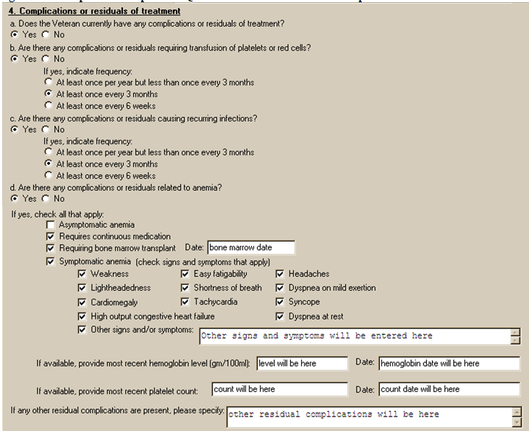

Figure 12: Print Example: DBQ – Leukemia – 4. Residual complications

4. Complications or residuals of treatment

------------------------------------------

a. Does the Veteran currently have any complications or residuals of treatment?

[X] Yes [ ] No

b. Are there any complications or residuals requiring transfusion of platelets

or red cells?

[X] Yes [ ] No

If yes, indicate frequency

[ ] At least once per year but less than once every 3 months

[X] At least once every 3 months

[ ] At least once every 6 weeks

c. Are there any complications or residuals causing recurring infections?

[X] Yes [ ] No

If yes, indicate frequency

[ ] At least once per year but less than once every 3 months

[X] At least once every 3 months

[ ] At least once every 6 weeks

d. Are there any complications or residuals related to anemia?

[X] Yes [ ] No

If yes, check all that apply:

[ ] Asymptomatic anemia

[X] Requires continuous medication

[X] Requiring bone marrow transplant Date: bone marrow date

[X] Symptomatic anemia (check signs and symptoms that apply)

[X] Weakness [X] Easy fatigability [X] Headaches

[X] Lightheadedness [X] Shortness of Breath

[X] Dyspnea on mild exertion

[X] Cardiomegaly [X] Tachycardia [X] Syncope

[X] High output congestive heart failure [X] Dyspnea at rest

[X] Other signs and/or symptoms: Other signs and symptoms will

be entered here

If available, provide most recent hemoglobin level(gm/100ml):

level will be here

Date: hemoglobin date will be here

If available, provide most recent platelet count: count will be

here

Date: count date will be here

If any other residual complications are present, please specify: other

residual complications will be here

Section 5. Functional impact
All questions in this section may be answered as described by the rules below. If all mandatory questions are not answered, the error message(s) will appear in a popup window as depicted below.

Table 6: Rules: DBQ – Leukemia – 5. Functional impact
Field/Question | Field Disposition | Valid Values | Format | Error Message
Does the Veteran’s B-cell leukemia impact his or her Veteran’s ability to work? | If diagnosis = Yes; Enabled, Mandatory, Choose one valid value  Else; Enabled, Optional | [Yes; No] | N/A | Please provide an answer to the question: Does the Veteran's B-cell leukemia impact his or her ability to work?
If yes, describe impact, providing one or more examples: | If Does the Veteran’s B-cell leukemia impact the Veteran’s ability to work = Yes; Enabled, Mandatory  Else; Disabled | N/A | Free Text | Please describe the impact of B-cell leukemia on the Veteran's ability to work, providing one or more examples.

Figure 13: Template Example: DBQ – Leukemia – 5. Functional impact
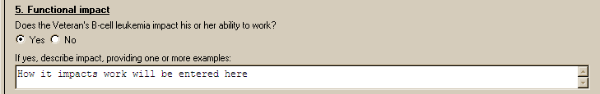

Figure 14: Print Example: DBQ – Leukemia – 5. Functional impact

5. Functional impact

--------------------

Does the Veteran's B-cell leukemia impact the Veteran's ability to work?

[X] Yes [ ] No

If yes, describe impact, providing one or more examples: How it impacts work

will be entered here

Section 6. Remarks
All questions in this section may be answered as described by the rules below.

Table 7: Rules: DBQ – Leukemia – 6. Remarks
Field/Question | Field Disposition | Valid Values | Format | Error Message
Remarks, if any | Enabled, Optional | N/A | Free Text | N/A

Figure 15: Template Example: DBQ – Leukemia – 6. Remarks
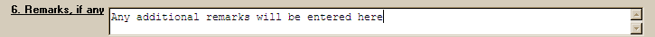

Figure 16: Print Example: DBQ – Leukemia – 6. Remarks

6. Remarks, if any

------------------

Any additional remarks will be entered here

Leukemia AMIE Worksheet
The AMIE worksheets are accessed via the [DVBA C PRINT BLANK C&P WORKSHE] Print Blank C&P Worksheet menu DBQ LEUKEMIA option.

Disability Benefits Questionnaire
Hairy Cell and other B-cell Leukemias

Name of patient/Veteran: _______________________ SSN: ________________

Your patient is applying to the U. S. Department of Veterans Affairs
(VA) for disability benefits. VA will consider the information you
provide on this questionnaire as part of their evaluation in processing
the Veteran's claim.

1. Diagnosis

Does the Veteran now have or has he/she ever been diagnosed
with hairy cell leukemia or any other B-cell leukemia?
___Yes ___No

NOTE: Provide only diagnoses that pertain to hairy cell or any other
B-cell leukemias

Diagnosis #1: _______________________
ICD code: ___________________________
Date of diagnosis #1: _______________

Diagnosis #2: _______________________
ICD code: ___________________________
Date of diagnosis #2: _______________

Diagnosis #3: _______________________
ICD code: ___________________________
Date of diagnosis #3: _______________

If additional diagnoses that pertain to hairy cell leukemia or any
other B-cell leukemia, list using above format: ___________________

2. Status of disease

___ Active ___ Remission

3. Treatment

____ The Veteran is currently undergoing treatment for this leukemia
with surgical, radiation, immunotherapy, antineoplastic chemotherapy
and/or other therapeutic procedures.

____ The Veteran has completed treatment for this leukemia.

Date of discontinuance of treatment: ______________

Page: 2

Disability Benefits Questionnaire for
Hairy Cell and other B-cell Leukemias

4. Complications or residuals of treatment

a. Does the Veteran currently have any complications or residuals of
treatment?

___Yes ___No

b. Are there any complications or residuals requiring transfusion of
platelets or red cells?

___Yes ___No

If yes, indicate frequency:

___ At least once per year but less than once every 3 months

___ At least once every 3 months

___ At least once every 6 weeks

c. Are there any complications or residuals causing recurring infections?

___Yes ___No

If yes, indicate frequency:

___ At least once per year but less than once every 3 months

___ At least once every 3 months

___ At least once every 6 weeks

Page: 3

Disability Benefits Questionnaire for
Hairy Cell and other B-cell Leukemias

d. Are there any complications or residuals related to anemia?

___Yes ___No

If yes, check all that apply:

___ Asymptomatic anemia

___ Requires continuous medication

___ Requiring bone marrow transplant Date:_________________

___ Symptomatic anemia (check signs and symptoms that apply)

__ Weakness __ Easy fatigability __ Headaches

__ Lightheadedness __ Shortness of breath

__ Dyspnea on mild exertion

__ Cardiomegaly __ Tachycardia __ Syncope

__ High output congestive heart failure __ Dyspnea at rest

___ Other signs and/or symptoms: _____________________________

_______________________________________________________________

If available, provide most recent hemoglobin level

(gm/100ml): _________ Date: ________

If available, provide most recent platelet count: _____ Date: ________

If any other residual complications are present, please specify: _____

______________________________________________________________________

Page: 4

Disability Benefits Questionnaire for
Hairy Cell and other B-cell Leukemias

5. Functional impact

Does the Veteran's B-cell leukemia impact his or her ability to work?

___Yes ___No

If yes, describe impact, providing one or more examples: _________________

__________________________________________________________________________

6. Remarks, if any __________________________________________________________

__________________________________________________________________________

Physician signature: __________________________________ Date: ______________

Physician printed name: ________________________________ Phone: _____________

Medical license #: _______________________

Physician address: __________________________________________________________

NOTE: VA may request additional medical information, including additional
examinations if necessary to complete VA's review of the Veteran's application.

